Solution for the first Report
% equation of motion of simple pendulum (Cartesian) function dotq = damped_pendulum_Cartesian (t,q)
global mass; global length; global grav; global alpha; global viscous;
x = q(1); y = q(2); vx = q(3); vy = q(4);
dotx = vx; doty = vy;
R = sqrt(x^2+(y-length)^2) - length;
P = 1/sqrt(x^2+(y-length)^2);
Rx = x*P; Ry = (y-length)*P;
Rxx = P - x^2*P^3;
Ryy = P - (y-length)^2*P^3;
Rxy = -x*(y-length)*P^3;
C = [vx,vy]*[Rxx, Rxy; Rxy, Ryy]*[vx;vy] ...
+ 2*alpha*[Rx, Ry]*[vx;vy]...
+ alpha^2*R;
fvx = - viscous*vx;
fvy = - viscous*vy;
A = [mass, 0, -Rx; 0, mass, -Ry; -Rx, -Ry, 0];
b = [ fvx; -mass*grav - fvy; C ];
s = A \ b;
dotvx = s(1); dotvy = s(2);
dotq = [dotx; doty; dotvx; dotvy];
end % solve the equation of motion of damped pendulum (Cartesian)
global mass; global length; global grav;
mass = 0.01; length = 2.0; grav = 9.8;
global alpha;
alpha = 1000;
global viscous;
viscous = 0.01;
interval = [0, 10];
qinit = [length*sin(pi/3); length*(1-cos(pi/3)); 0; 0];
[time, q] = ode45(@damped_pendulum_Cartesian, interval, qinit);
% time - x and y
plot(time,q(:,1),'-', time,q(:,2),'--');
title('time and position');
xlabel('time');
ylabel('position X and Y');
legend('X','Y');
saveas(gcf, 'damped_pendulum_Cartesian_x_y.png');
figure;
% time - vx and vy
plot(time,q(:,3),'-', time,q(:,4),'--');
title('time and velocity');
xlabel('time');
ylabel('velocity along X and Y');
legend('vx','vy');
saveas(gcf, 'damped_pendulum_Cartesian_vx_vy.png');
figure;
% x - y
plot(q(:,1), q(:,2));
title('damped pendulum Cartesian path')
xlabel('position along x');
ylabel('position along y');
saveas(gcf, 'damped_pendulum_Cartesian_path.png');
figure;
% computed pendulum angle
angle = atan2(q(:,1), length-q(:,2));
plot(time, angle);
title('damped pendulum Cartesian computed angle');
xlabel('time');
ylabel('angle');
saveas(gcf, 'damped_pendulum_Cartesian_computed_angle.png');
figure;
% constraint
R = sqrt(q(:,1).^2 + (q(:,2)-length).^2)-length;
plot(time, R);
title('damped pendulum cartesian R');
xlabel('time');
ylabel('constraint R');
saveas(gcf, 'damped_pendulum_Cartesian_R.png');
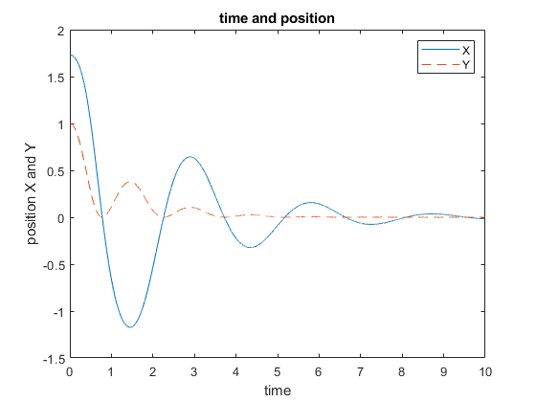
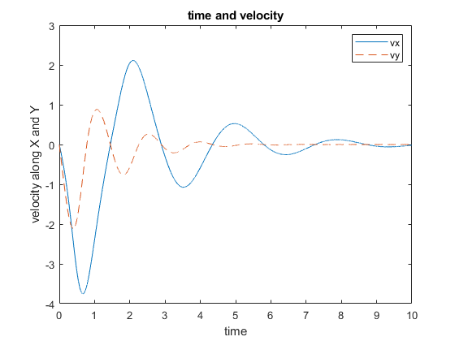
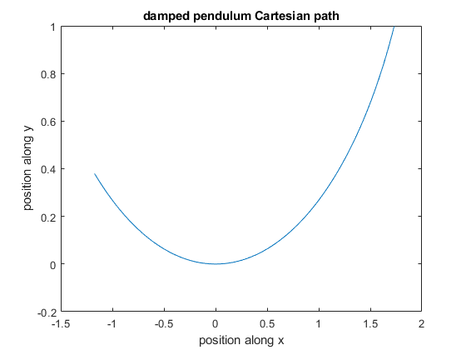
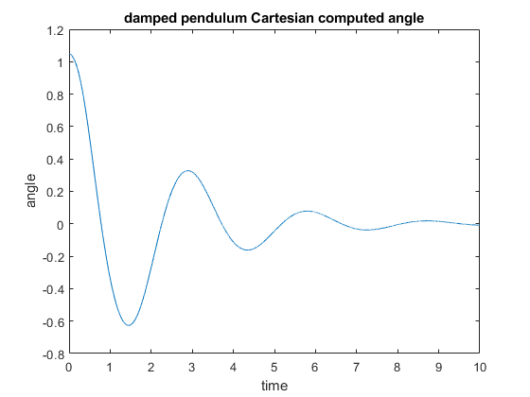
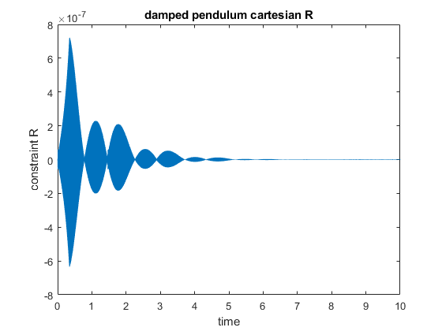
Published with MATLAB® R2022b

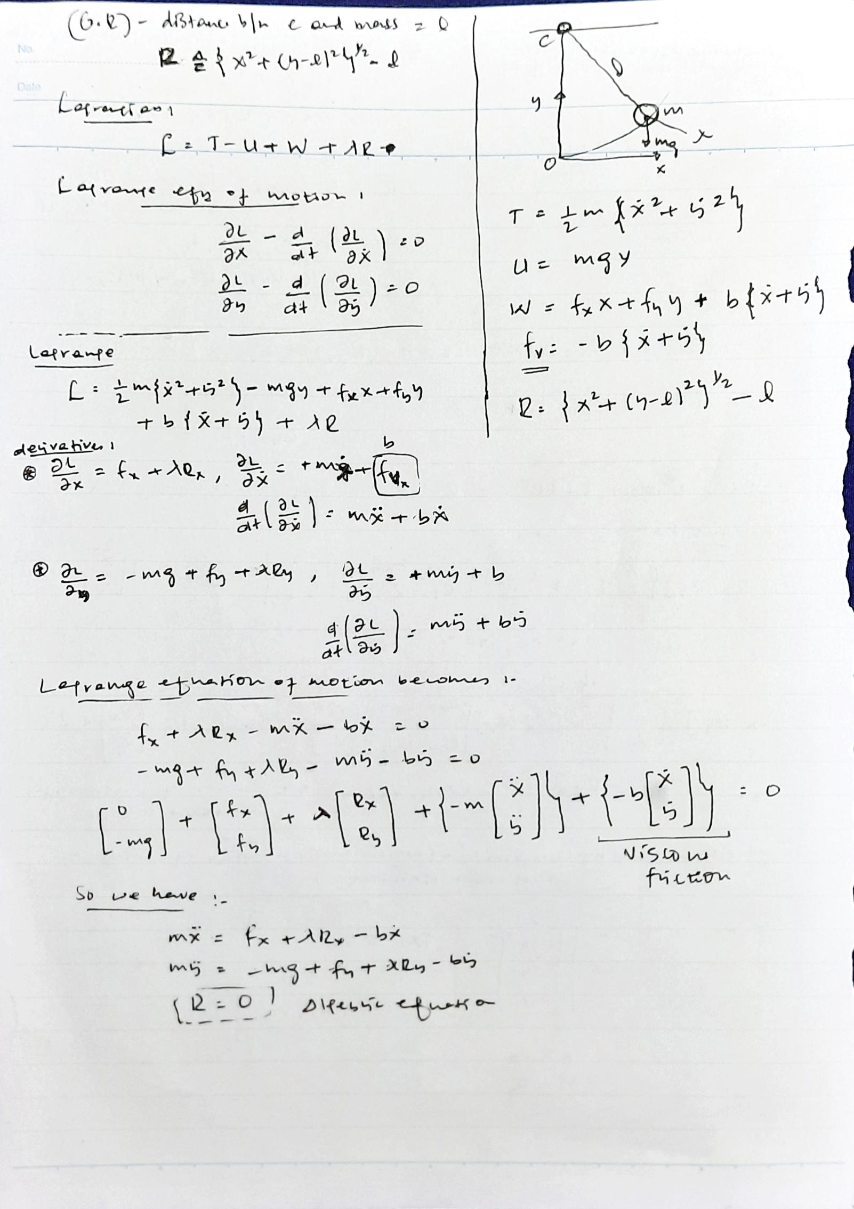
Derivation:

